How to Sync files with OneDrive in Windows
Note: If you don’t currently have an account (@ucsd.edu or @health.ucsd.edu) signed in to OneDrive, use these instructions to start OneDrive.
- Select the Start button, search for “OneDrive”, and then open it:
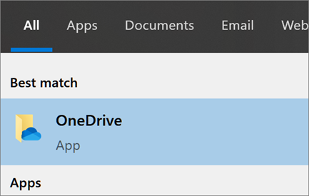
- When OneDrive Setup starts, enter your @health account (JoeSmith@Health.ucsd.edu), and Click on Sign in.
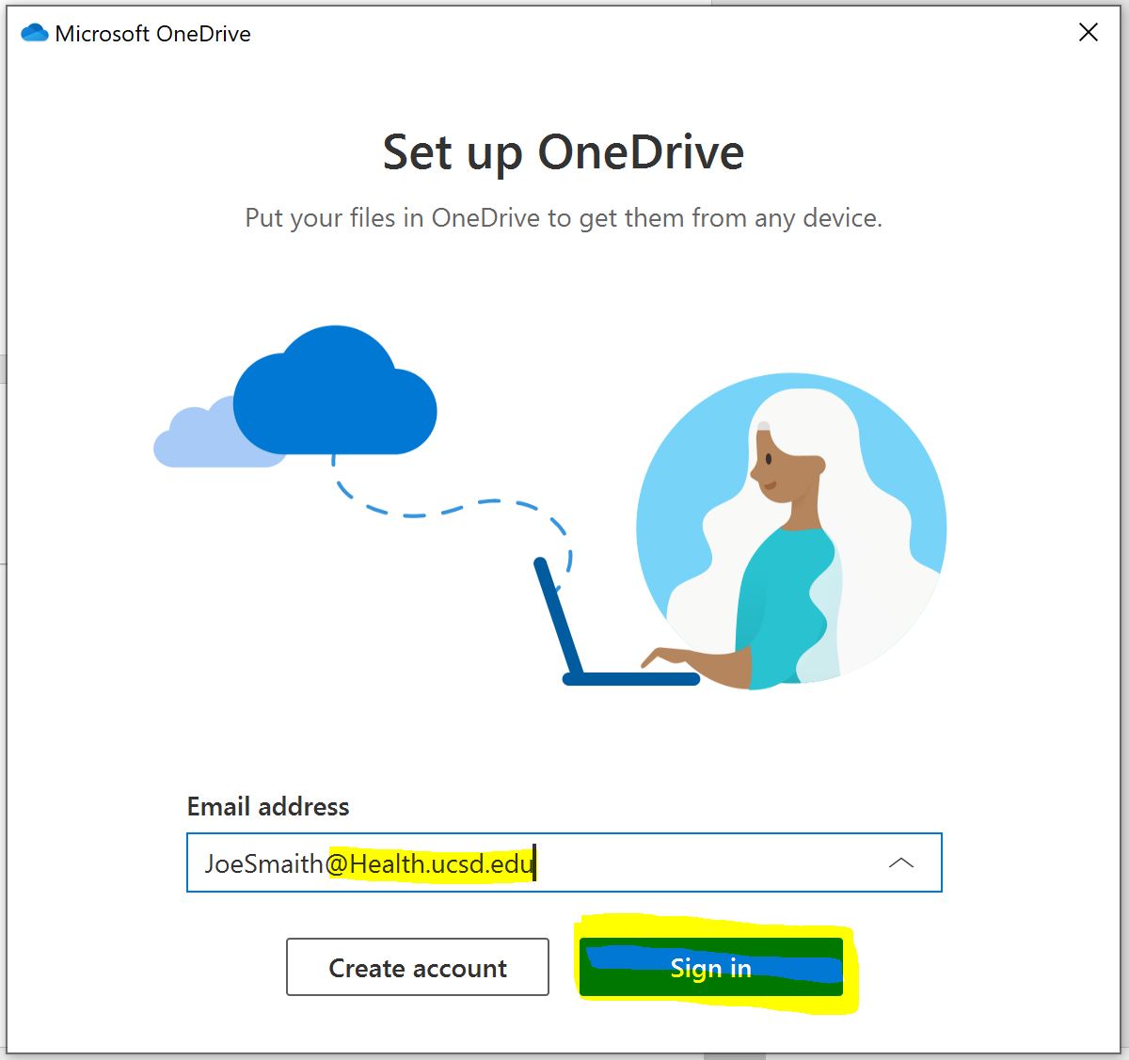
- On “Your OneDrive folder” screen, click Next to accept the default folder location for your OneDrive files. If you want to change the folder location, select Change location - this is the best time to make this change.
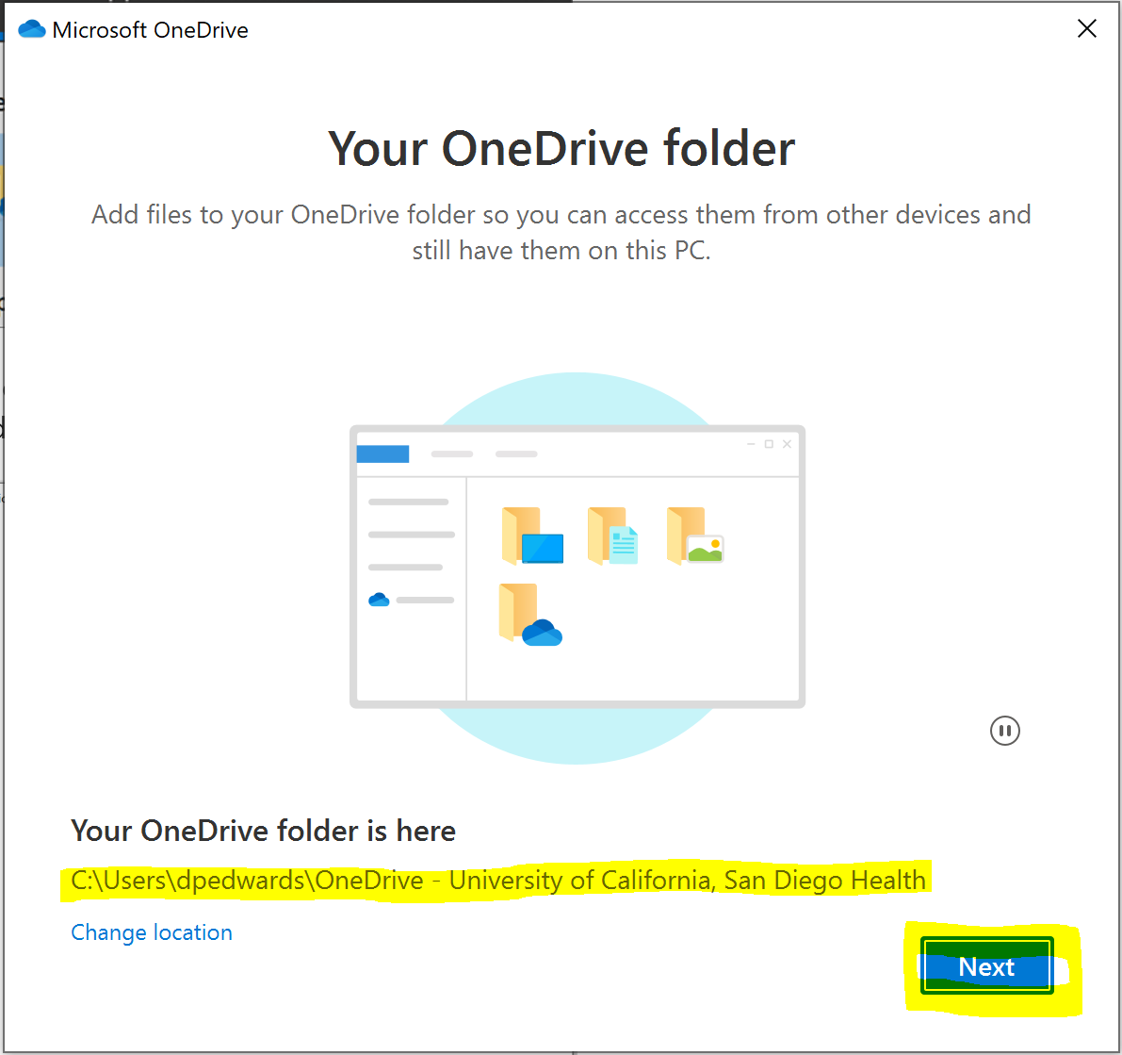
- If the folder location already exist then the App will ask you to “Use this folder” or Choose a new folder”
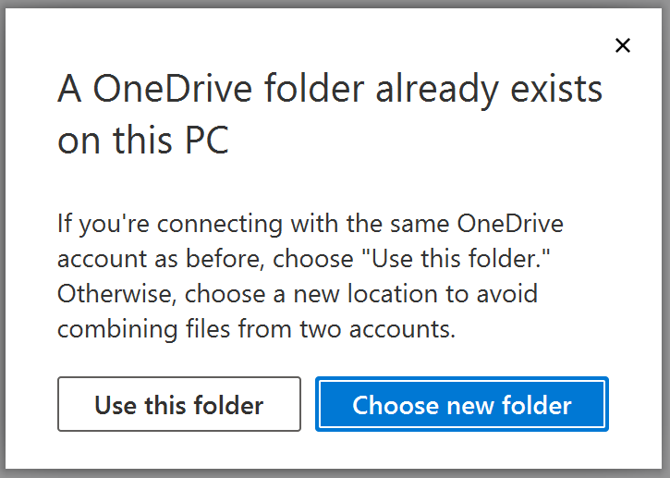
- On the next page you get to select which folder to back up automatic. Please unselect “Desktop” option. Click on Continue
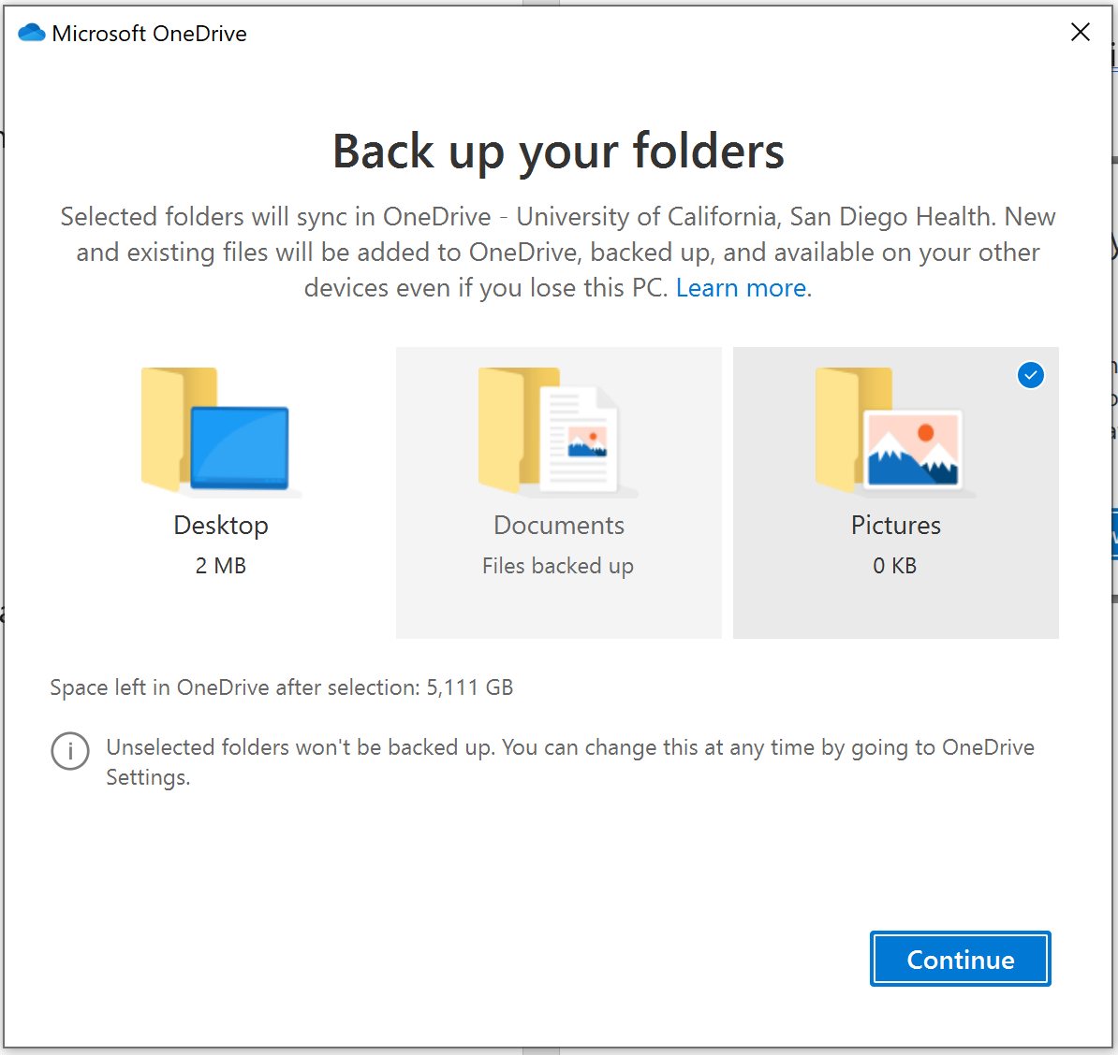
- On the “Get to Know your OneDrive” screen, you will be able to drag and drop your files to you @Health OneDrive. Select Next when you are done
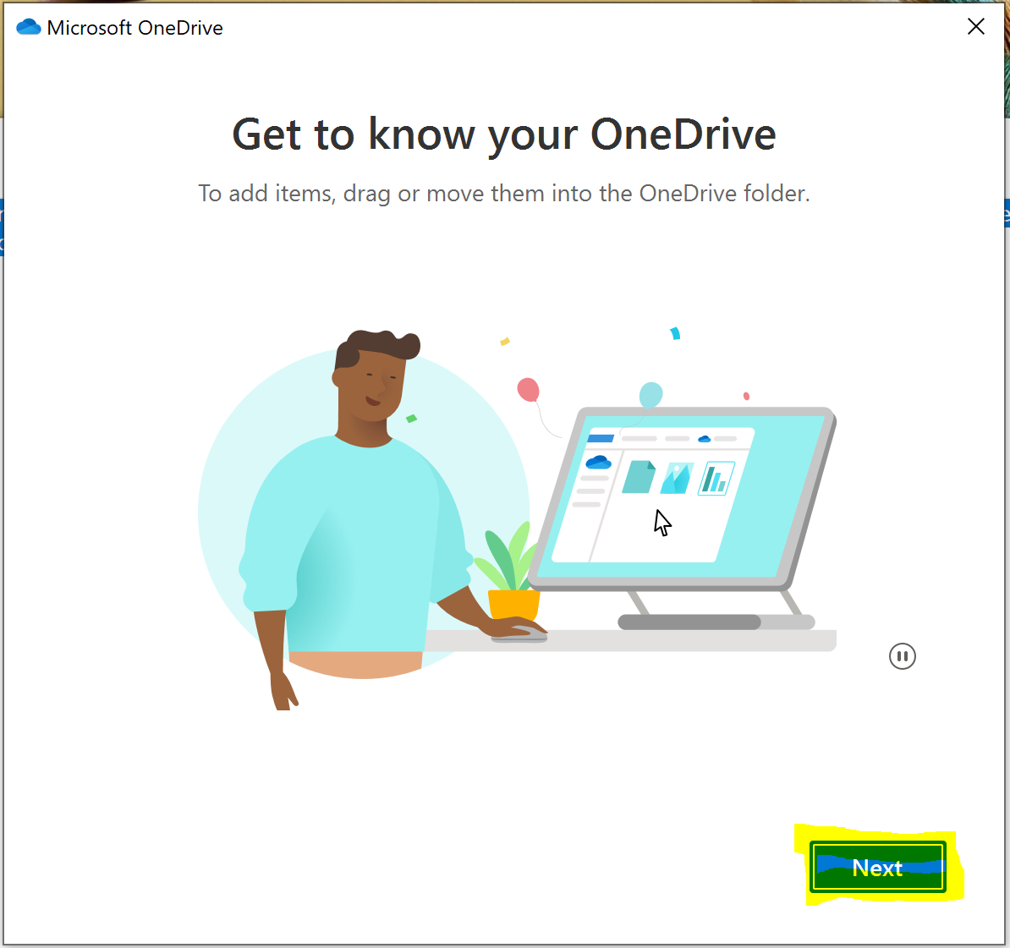
- Click next on “How to share files” screen

- The next screen explains the file icons (Online-Only, On this device, and Always available). Files On-Demand helps you access all your files in OneDrive without having to download all of them and use storage space on your Windows device. Select Next.
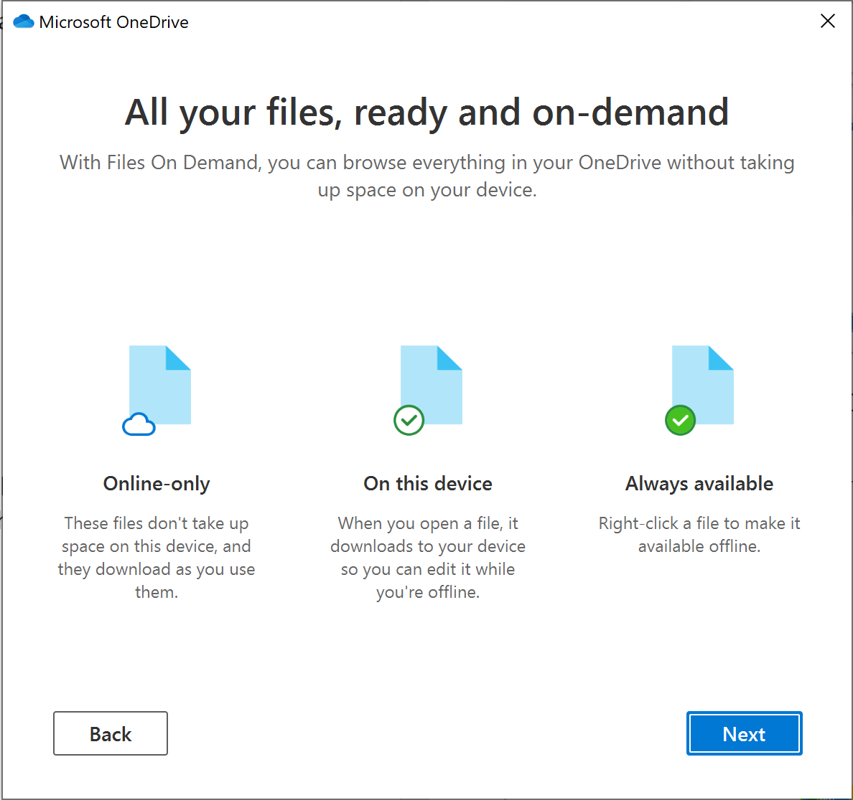
- Just click on “Later” for “Get the mobile App”
- Click on “Open my OneDrive folder”
